
Seminar
Succession and Whanau Trusts
Researching Whenua Land and Whakapapa
Being an active owner
General Q & A
7 February 2019
Time: 2.00pm – 3.30pm
Presenter: Dee Turner - – Ngāti Maniapoto, Ngāti Whakatere
Venue: Community Law 14 Market Street, Blenheim.

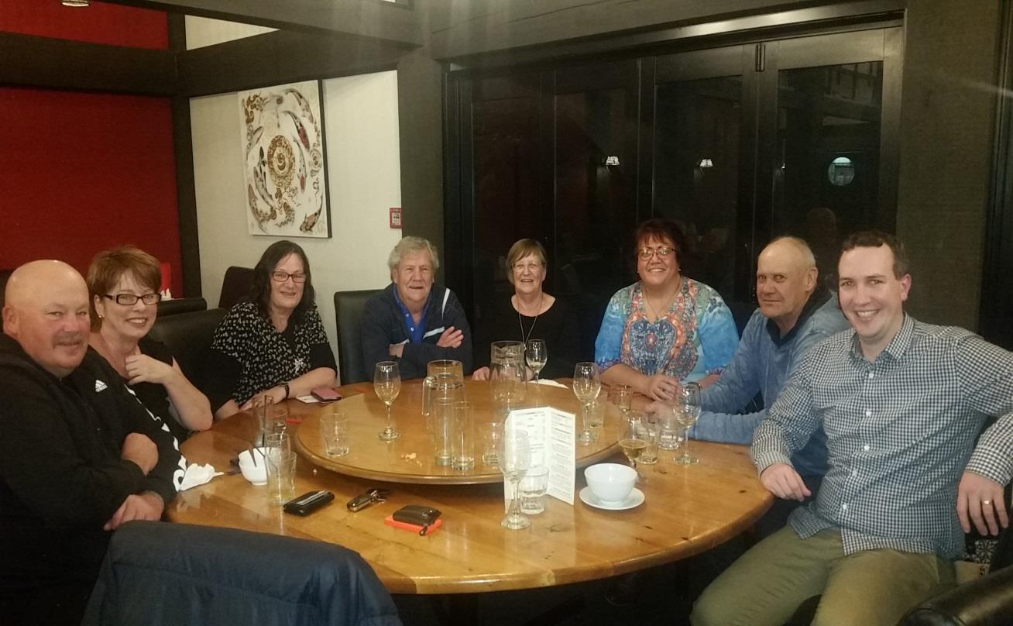

Dee has previously worked in the Māori Land Court. Dee has been an advisory officer providing information and advice to whānau regarding their Māori Land.
She has also worked at the office for the Chief Judge of the Māori Land Court processing applications to correct the historical Māori Land Court record which involved researching whakapapa and drafting reports.
Dee is passionate about helping whānau navigate their way through the Māori Land Court process and to provide quality information and advice around this.
Dee is currently working for the Community Law organisation as a Māori Liaison Officer and Case Worker. She is also completing study towards becoming a Legal Executive.
She welcomes whānau to come and attend this informal presentation/kōrero and looks forward to meeting with you.

Dee is passionate about helping whānau navigate their way through the Māori Land Court process and to provide quality information and advice around this.
Dee is currently working for the Community Law organisation as a Māori Liaison Officer and Case Worker. She is also completing study towards becoming a Legal Executive.
She welcomes whānau to come and attend this informal presentation/kōrero and looks forward to meeting with you.

Please email reception@commlawmarlb.org.nz to secure your place and for catering purposes

