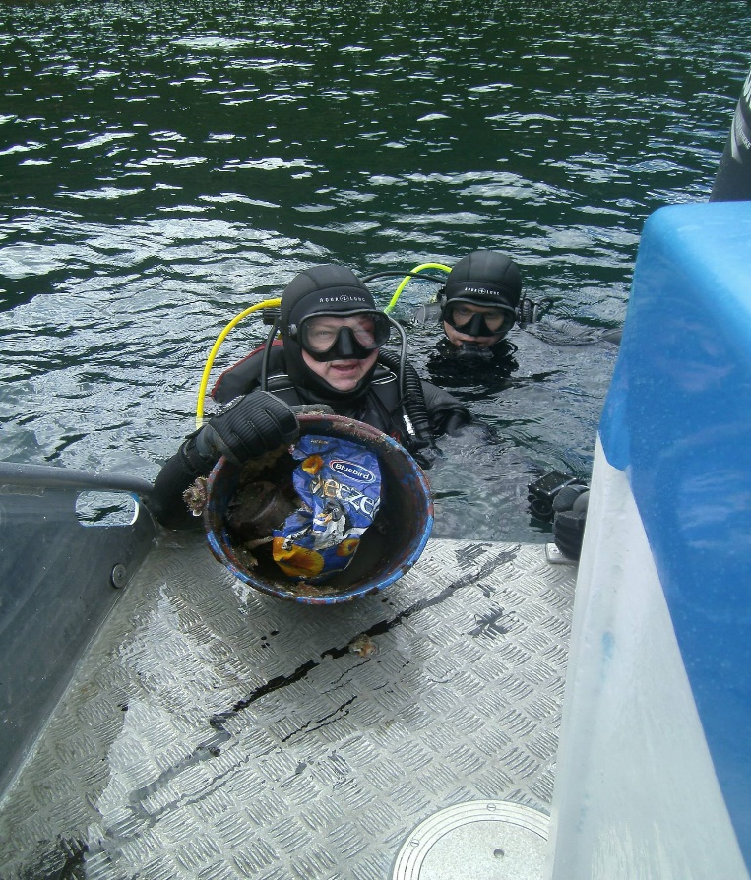
“TRASH to TREASURE”
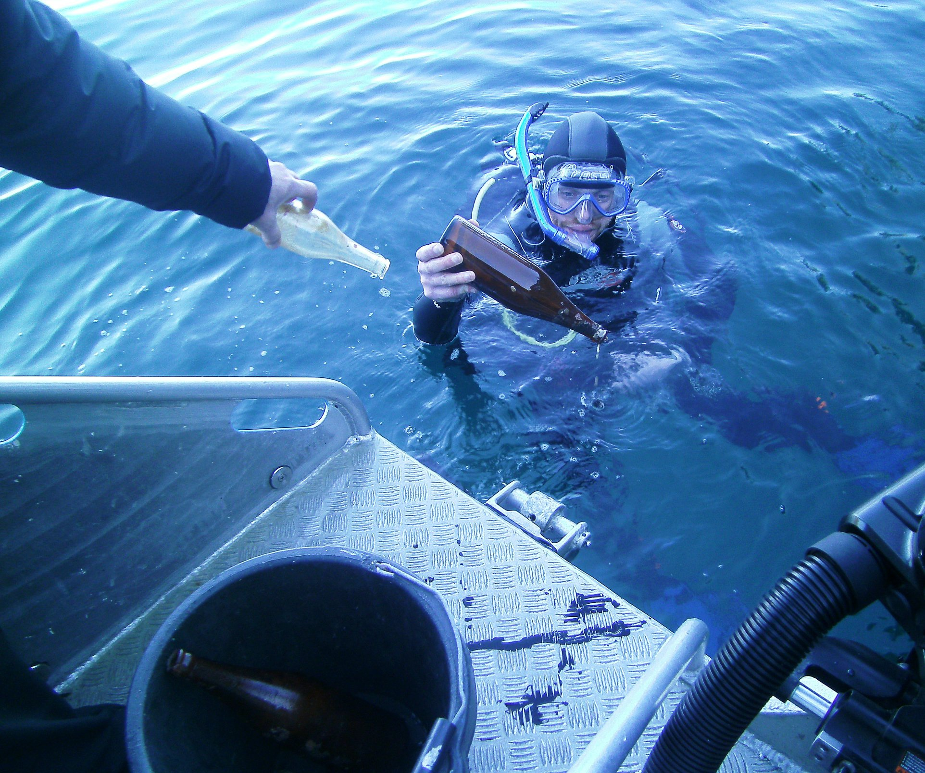
Calling all divers to our “Trash to Treasure” Competition. For the month of September, we are asking divers to go out and collect some underwater rubbish. Marlborough Sounds is a paradise that needs looking after and as divers we see what others don’t. This competition includes any rubbish from a waterway and has been underwater and shows signs of being underwater. Snorkelers, free divers and scuba divers this is for you. Bring your rubbish to Waikawa Dive Centre and receive points for each piece you deliver. The divers that collect the most rubbish and gain the most points stand to win some amazing prizes.
You do need to register to enter.
Waikawa Dive Centre. 7 Marina Drive Waikawa. PICTON
Ph 573 5939 Email - waikawadive@xtra.co.nz Photos are taken in Queen Charlotte Sound 2019, by divers on scenic recreational dives. Over 2k prize pool. Caring Sponsors are Cressi NZ, Marlborough Sounds Marinas, Baywood Homes, Marlborough District Council, SSI NZ

