**Mākete Pō Night Market : Information for stall holders**

Nau mai haere mai – Thank you for taking part in Mākete Pō o Whakatū Night Market

Mākete Pō is centred on whānau in a vibrant Nelson location of Kirby Lane 105 Bridge Street offering a relaxing stroll through market feel with an entertaining atmosphere. This is the first night market celebrating whānau hapu iwi enterprises in a vibrant Nelson CBD location and we are keen for our community to get behind this event. This event is held under the korowai of the “Economic Pou group” and our major sponsor for this event is Te Rūnanga o Ngāti Kuia. The Night Market is alcohol and smoke free.

**Stall sites:** Kirby Lane has **22** 3 x 3 metres spaces dedicated to stall sites. We are hoping to increase this number into the business car park at the entrance which may give us more sites. The surface of Kirby Lane is sealed ash felt and concrete. Each stall holder will be allocated a site number with an assigned location. A gazebo (no larger than 3m x 3m) or similar weather proofing is encouraged as this will be an all-weather event. You will also need to supply any furniture that you require for your stand, such as tables and chairs. The gazebo and any furniture must be contained within the 3m x 3m allotment.

**Set-up times:** Kirby Lane has one main entrance and is tight for space and room for vehicles to manoeuvre. All vehicle access to Kirby Lane must be supervised by our site coordinators. We will also be allocating set-up times based on your use of vehicles or carry-ins. At registration you will be asked to choose a preferred set up time which we will try to accommodation as much as possible. The committee will confirm the staggered set up time schedule.

**Open and closing times:** Mākete Pō will formally open at 4pm. Prior to 4pm a coordinator will check each stall regarding compliance with conditions of use as listed below. The Night Market will conclude at 8pm. All stalls are expected to remain in place for the entire duration; no stalls are to be packed up prior to 8pm. Kirby Lane must be vacated by 10pm.

**Site Coordinators** (in fluoro vests) will be on site from 12 noon to assist you to locate your allocated stall site (which will be numbered) and answer any other questions you have.

**Water:** If you need water for your stall, you will need to bring your own hose.

**Electricity:** There are limited power points available so please let us know if you will need access to power. If you do need power then please use certified power cords. Generators are not permitted without prior consent.

**Rubbish:** Wheelie bins provided for the convenience of Mākete Pō patrons are not to be used for waste generated by stall holders. Please bring your own rubbish bags and or rubbish bin for your stall. You must ensure that you leave the lane the way you found it -clean and clear. All waste generated by a stall holder has to be removed by the stall holder by 10pm. Any waste or damage not taken care of will be on-charged to the stallholder.

**Registering for a stall site:** If you would like a site for your business please get in touch with our stall management contact: TeRa Morris email [maketepowhakatu@gmail.com](mailto:maketepowhakatu@gmail.com) or cell 021943983 and we will send you a registration form. Registrations must be received by Friday 23 November. The committee will then map the stalls and send confirmation of stall site allocations, and any pre-market information.

**Health and safety and other regulations** Stall holders will need to take personal responsibility to comply with all appropriate regulations and license conditions including OSH public health and licensing requirements.

**Mākete Pō Night Market : Registration for stall holders**

In order to secure a stall at Mākete Pō please complete the form below and send it to [maketepowhakatu@gmail.com](mailto:maketepowhakatu@gmail.com)

**Please note that:**

* Registrations must be received by Friday 23 November. The committee will then map the stalls and send confirmation of stall site allocations, and any pre-market information.
* While we will do everything possible to cater to the registrations, interest may exceed the number of stall sites available and the committee may need to rationalise the registrations. The committee will confirm the allocations of stalls as soon as possible after the registration close date.

|  |  |
| --- | --- |
| First name |  |
| Last name |  |
| Address |  |
| Email address |  |
| Phone | Note that mobile phone is preferred so that we can also contact you on the day if needed |
| Iwi affiliation | List Iwi / runanga / hapu affiliation |
| Name of your business |  |
| Product | List here the produce, product or service you are selling |
| Nature of business | Please write a short description of your enterprise |
| Utilities required | Yes/No Water  Yes/No Power |
| Preferred set up time (you may tick more than one) | Yes/No **Early birds** between 12 noon and 1pm  Yes/No **Cruising** between 1pm and 2pm  Yes/No **Still room** between 2pm and 3pm  Yes/No **Rush hour** 3pm to 3:40pm will be limited to carry in setup only |
| Vehicle access to set up | Yes/No Car  Yes/NoTrailer  Yes/NoCarry-in (no vehicle required) |

**Confirmation and declaration**

I will abide by the health, safety and regulatory requirements of the market and Kirby Lane.

**This registration is completed by: ­ *(Type or sign your name here)* on *(date)***

Note that an email of this document from your address will be treated the same as a signed registration.

**Mākete Pō Night Market : Eventfinda advertisement**

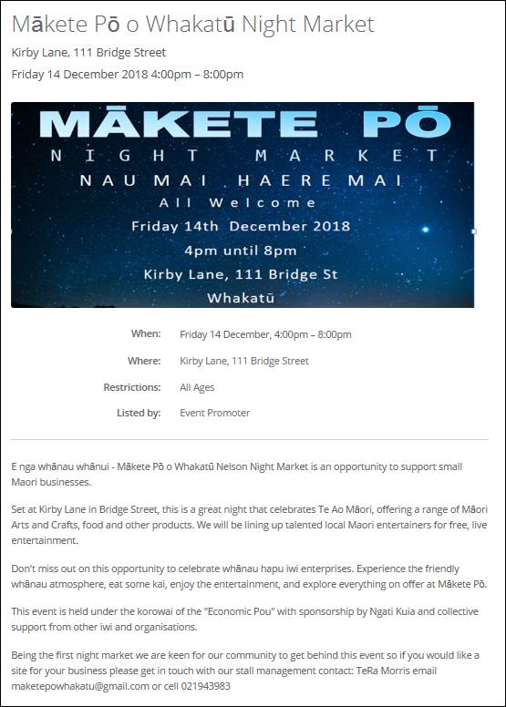

**TEXT:**

E nga whānau whānui - Mākete Pō o Whakatū Nelson Night Market is an opportunity to support small Maori businesses.

Set at Kirby Lane in Bridge Street, this is a great night that celebrates Te Ao Māori, offering a range of Māori Arts and Crafts, food and other products.  We will be lining up talented local Maori entertainers for free, live entertainment.

Don't miss out on this opportunity to celebrate whānau hapu iwi enterprises.  Experience the friendly whānau atmosphere, eat some kai, enjoy the entertainment, and explore everything on offer at Mākete Pō.

This event is held under the korowai of the "Economic Pou" with sponsorship by Ngati Kuia and collective support from other iwi and organisations.

Being the first night market we are keen for our community to get behind this event so if you would like a site for your business please get in touch with our stall management contact: TeRa Morris email [maketepowhakatu@gmail.com](mailto:maketepowhakatu@gmail.com) or cell 021943983